Draw a UML diagram for hotel reservation system. In a hotel reservation system,acustomer can make online booking for a hotel, by specifying the accommodation requirements such as type of room (AC/Non-AC, One bed/two bed), total no of rooms, duration of stay. The system selects a suitable hotel as per customer’s requirements. If a hotel is found then the availability of rooms in that hotel is checked. The charges are calculated for the selected requirement and these are acknowledged to the customer. If the customer is satisfactory about the selection made by the system, then he confirms the reservation.

### Aim

To design a Hotel Reservation System using UML diagrams, ensuring the system fulfills the requirements for booking hotels, checking availability, calculating charges, and managing reservations.

### Procedure

1. Requirement Analysis:
   * Understand the functional requirements of the system, including room booking, availability checking, charges calculation, and payment processing.
2. Identify Key Entities:
   * Determine the major components of the system, such as Customer, Reservation, Room, Hotel, Payment, and System.
3. Define Attributes and Methods:
   * For each identified entity, define relevant attributes (data members) and methods (functions) to fulfill the required functionalities.
4. Establish Relationships:
   * Map out how the entities are related to each other, such as associations, compositions, and aggregations.
5. Draw the UML Diagram:
   * Represent the entities (classes) as rectangles.
   * List attributes and methods in each class.
   * Use appropriate arrows and notations to show relationships, such as association (simple lines), aggregation (hollow diamonds), and composition (solid diamonds).
6. Validation:
   * Cross-check the diagram with the requirements to ensure all functionalities are covered

Usecase diagram

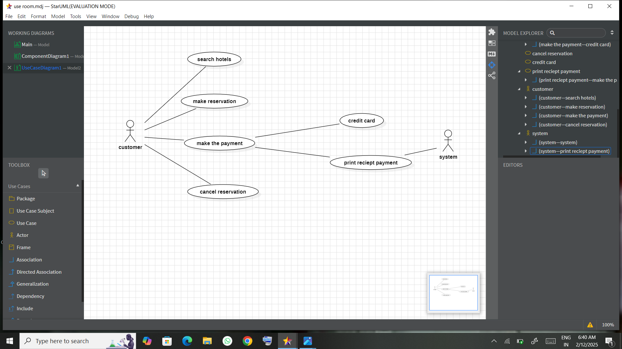

Class diagram

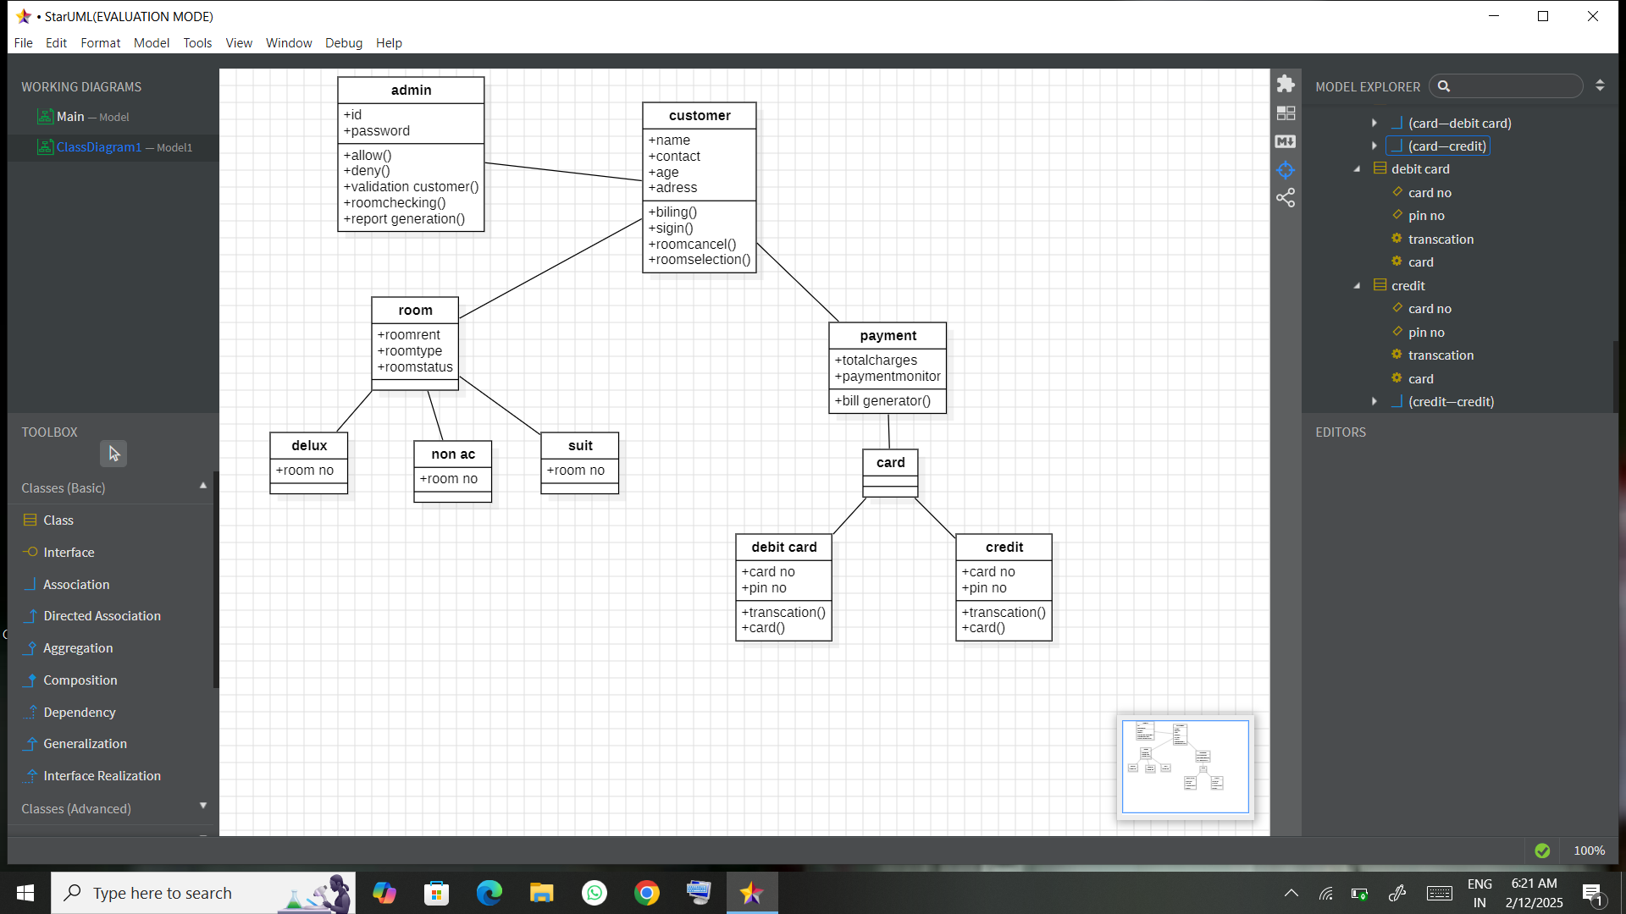

Sequence diagram

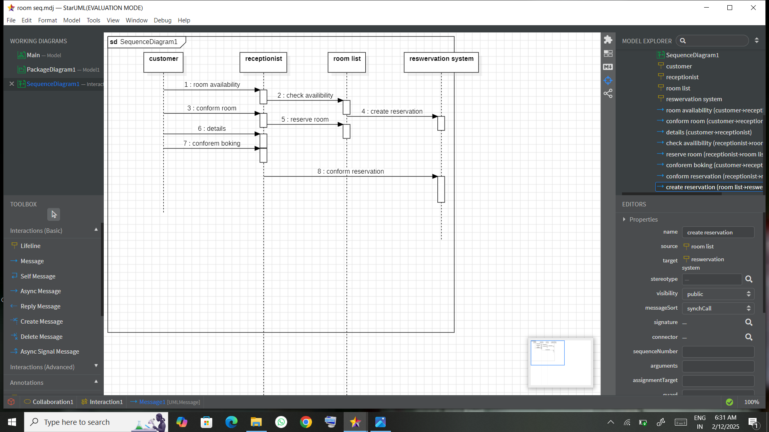

Deployment diagram

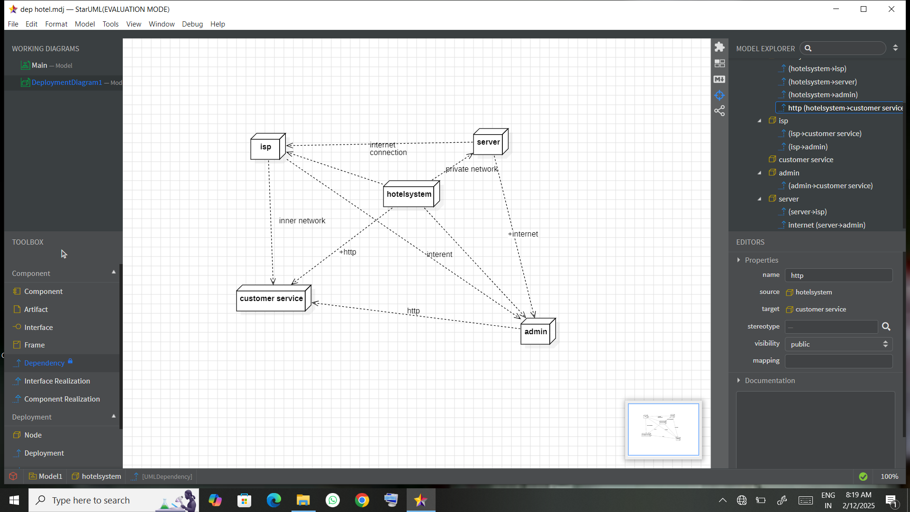

Package diagram

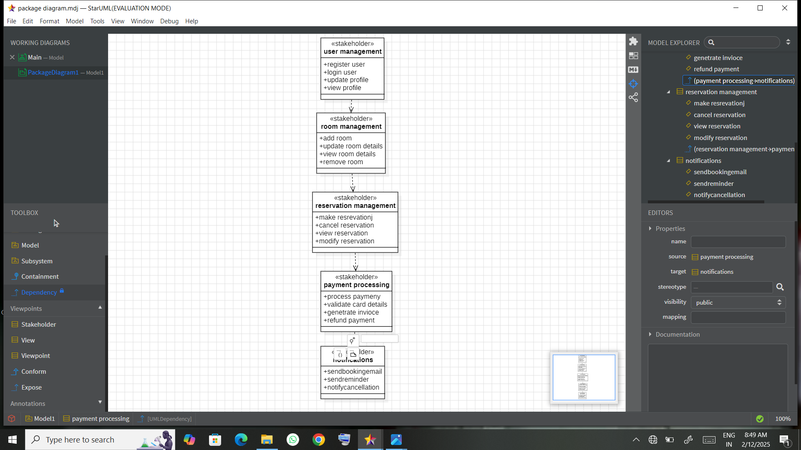

State diagram

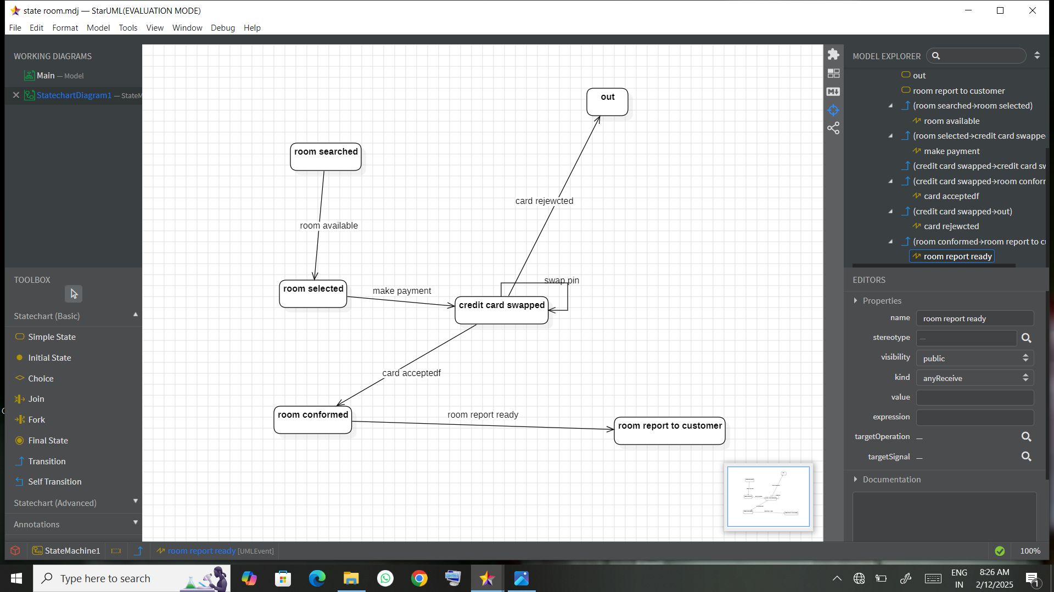

Activity diagram

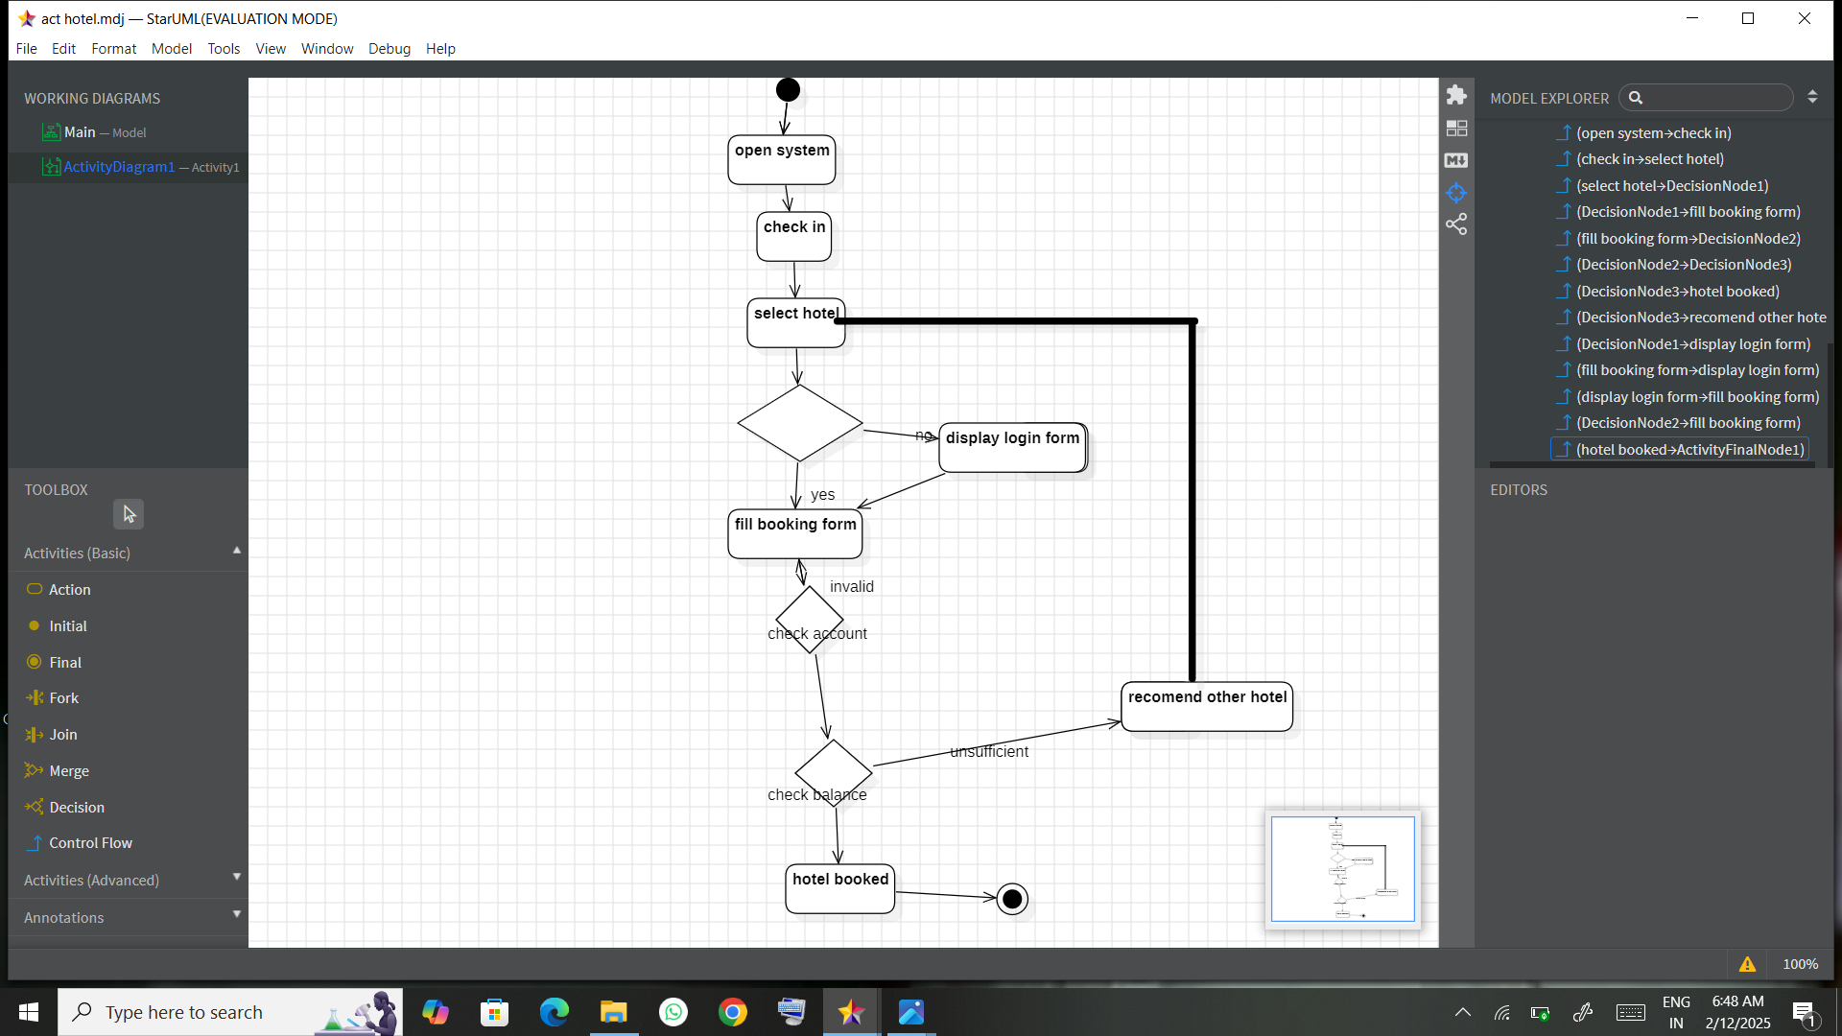

Component diagram

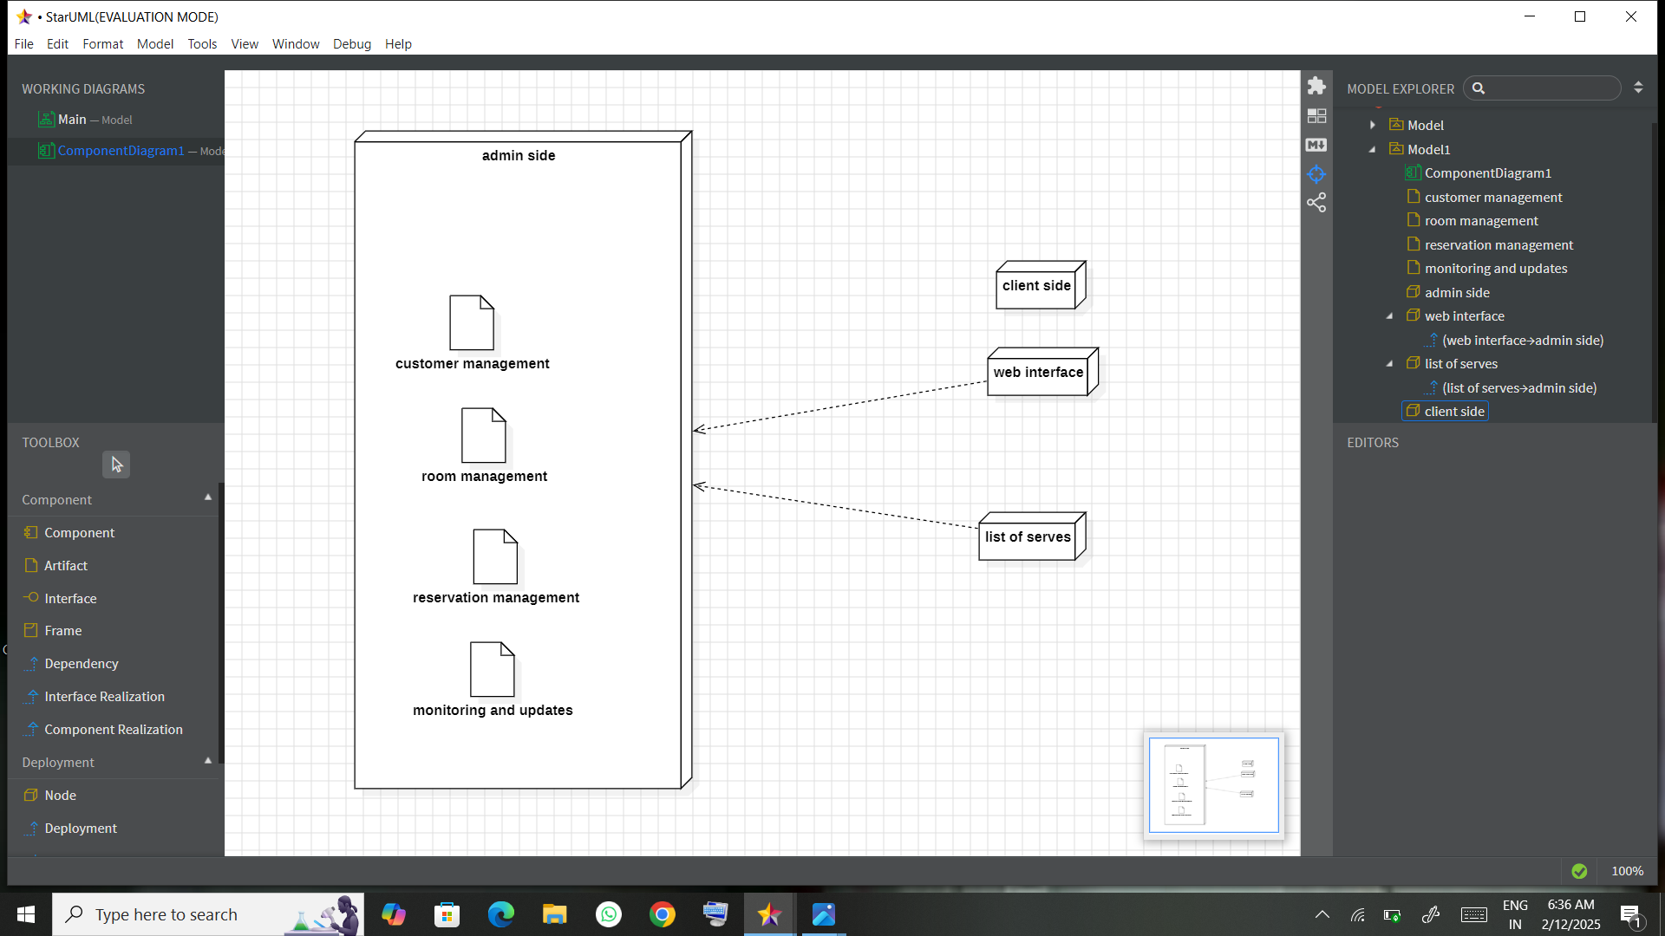

Collaboration diagram

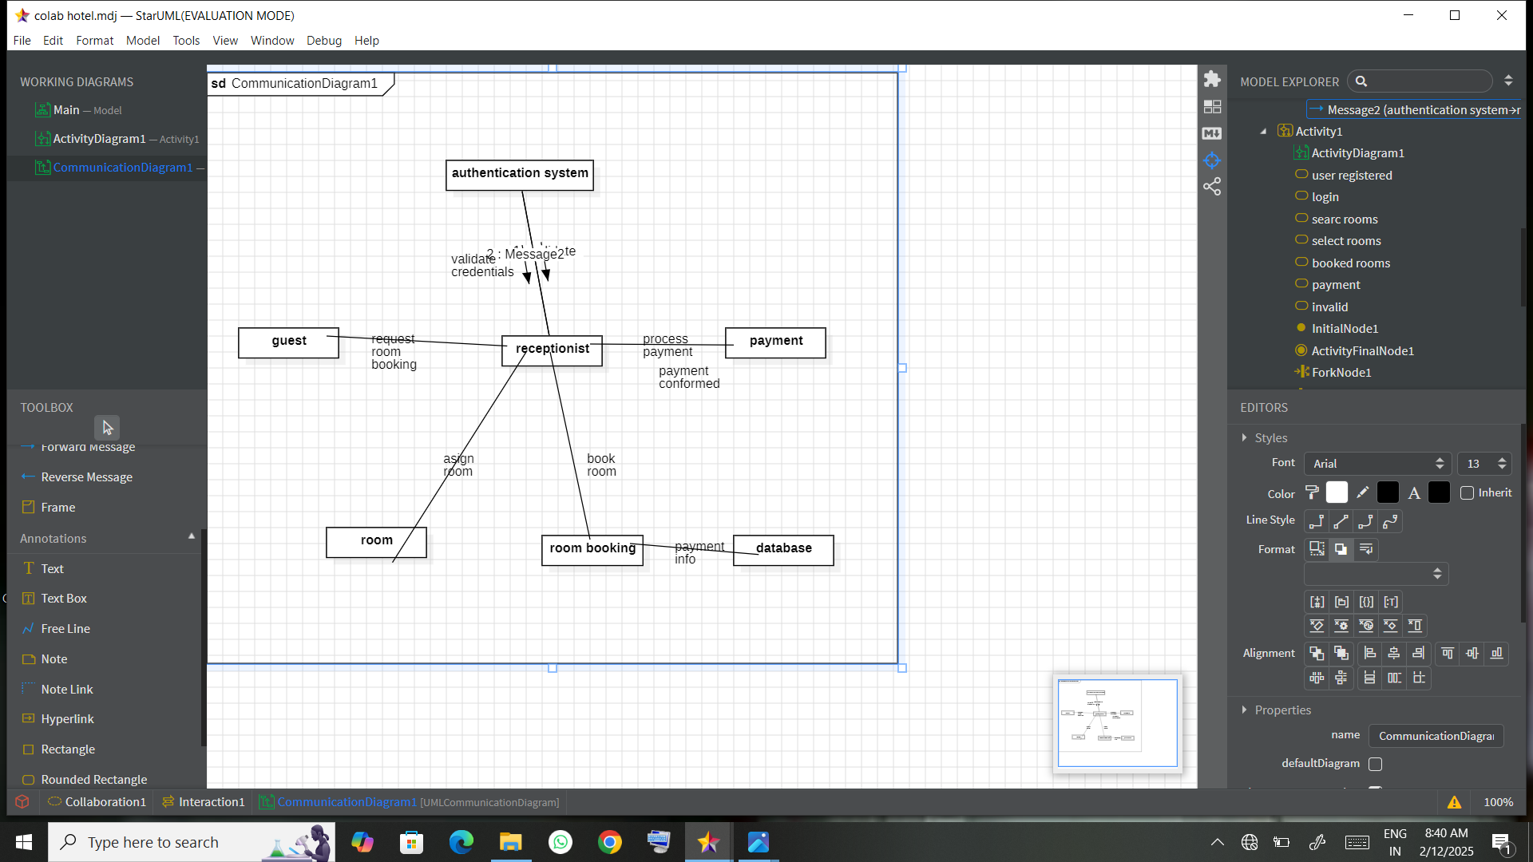

### Result

A well-structured UML class diagram was created, illustrating the Hotel Reservation System. The diagram includes:

* Entities such as Customer, Reservation, Room, Hotel, Payment, and System with their attributes and methods.
* Relationships between entities like interaction, association, and composition.
* Workflow clarity, which aids developers and stakeholders in understanding the system architecture and implementation.